

2025 Research Funding Grant Guidelines Round 1

Safety of people with disability

Plain language

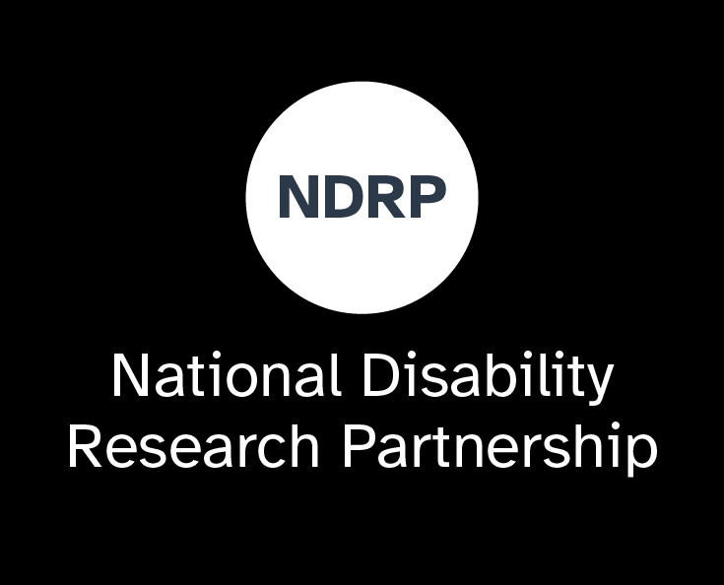

NDRP 2025 research funding grant guidelines Round 1

**Contents**

About us 1

About this Grant Guideline 1

Our 2025 research topic – safety of people with disability 1

About this grant 1

Stream 1 – co-design of research proposals 2

Stream 2 – knowledge synthesis projects 2

Our goals 2

Budgets 3

How you can spend the funding 3

In-kind contributions 3

Timeframes 3

Project deliverables 4

Who can apply for funding? 4

Who is not eligible to apply for funding? 5

Project Leads, project team members and partners 5

Project Lead 5

Project team members 5

Partner organisations 6

How we choose projects to fund and support 6

How to apply for funding 6

Summary 8

## About us

The National Disability Research Partnership (NDRP) funds research that is:

* led by people with disability
* done with people with disability.

The research will create evidence to help shape policies that promote the rights of people with disability.

We are a not-for-profit charitable organisation.

An independent board leads our organisation. Our research committee oversees our research program. Our staff support the research activities.

For more information about our roles and responsibilities, visit our [website](https://www.ndrp.org.au/research/research-policy).

## About this Grant Guideline

This guideline explains the objectives, intended outcomes, eligibility requirements and assessment criteria for the grant.

You can read more about our funding program, research agenda, principles and application process in our [overview document](https://www.ndrp.org.au/research/2025-research-funding#:~:text=Guide%20for%20SmartyGrants.-,Round%201%20key%20documents,-To%20apply%20for).

You can also read about our roles and responsibilities in our [research funding policy document](https://www.ndrp.org.au/research/research-policy).

## Our 2025 research topic – safety of people with disability

In 2025, the research we fund and support will focus on the safety of people with disability in Australia.

To be safe means having the support and resources to take part in society and live an independent life. To feel safe means feeling respected, valued, heard and protected.

## About this grant

Applications open **17 March 2025**.

Applications close **28 April 2025**.

We are inviting organisations to apply for funding to do research activities by and with people with disability. We will fund and support short-term research projects that use co-design approaches.

The grant funding will allow for the time and resources required to:

* prepare the research
* build relationships
* share knowledge
* do the research activities.

There will be 2 streams of funding.

#### Stream 1 – co-design of research proposals

Develop a research proposal that outlines future research projects about the safety of people with disability.

A research proposal is a written plan that outlines the future research project you would like to do on the topic. It includes what you want to research, the questions you aim to answer, why the research is needed and how you plan to research it.

#### Stream 2 – knowledge synthesis projects

Find evidence and knowledge that already exists about the safety of people with disability. Bring this knowledge together and review it. Use the information from the review in useful materials that can help change policy and practices.

Our goals

Our goals are to bring people together and support them to:

* understand a topic about the safety of people with disability
* find new ways of working that involve co-design of research
* strengthen research partnerships
* produce high-quality research that changes policy and practice.

## Budgets

You can apply for up to $60,000 per project. The total funding available is $600,000.

### How you can spend the funding

You can use the grant money for activities related to the research project. For example:

* wages
* payments for people who are not paid a wage for their role in the project
* reasonable travel and accommodation costs
* costs to host meetings, including catering
* aids to support inclusive participation (e.g. Easy Read, Auslan, captioning, interpreters, translation)
* some equipment or items to support inclusion and accessibility
* training activities (e.g. LGBTQIA+ inclusion training).

You cannot use the grant money for:

* organisational fees (e.g. admin, infrastructure, overheads)
* the purchase of major equipment
* subcontracting large parts of the project to people or organisations who are not listed as team members or partners.

### In-kind contributions

You must include ‘in-kind’ contributions by people or organisations in the budget with an approximate value.

## Timeframes

Project timeframe: 6 to 10 months.

Projects that get funding grants must start in June or July 2025.

We understand that it takes time to develop relationships and plan for inclusive, disability-led research. Some projects need a slower pace than others. This is important, and OK. We encourage you to explain what you can get done in 6 to 10 months in your application. Only apply for projects you feel confident your team can deliver on time.

## Project deliverables

All project teams must:

* write a mid-project report using our template and meet with us to discuss how the project is going
* develop recommendations about how to communicate the research findings to end-users
* contribute to a content series to showcase projects and share knowledge.

Project teams in stream 1 must write a final-project report in plain language, using our template. This report will include an outline of the research proposal that has been co-designed, the team’s plan to fund the research and the lessons learned during the project.

Project teams in stream 2 must write a research report in plain language that we will publish. It must outline the existing evidence and gaps in relation to the topic. The report should be a maximum of 70 pages including references and appendices.

All funded teams own the Intellectual Property (IP) on the research materials produced. We hold publishing rights on most of the materials produced by the project teams.

## Who can apply for funding?

We want people and organisations to work together on research projects.

The project team must nominate one organisation to apply as the ‘Lead Organisation’. Any organisation that has an Australian Business Number (ABN) can do this role. The Lead Organisation must be able to manage and deliver the research project.

The project team should include:

* people with disability, including people with direct experience of the topic, issue or opportunity that the project will address (sometimes called ‘consumers’)
* people who can help to change disability policy and practices
* researchers who understand inclusive disability research.

Projects can be community-led or university-led.

Projects must use co-design approaches. They must also align with our principles. We encourage applicants to read our principles. You can also visit our website to read an [Easy Read version of our principles](https://protect.checkpoint.com/v2/r04/___https://www.ndrp.org.au/principles___.Y3A0YTpuZHJwOmM6bzo2YTVkYzVlYWMxNmE0ODY0MTM5NDQwZWZkMzVhYjUyMTo3OjM1ZWE6YmRmNmRiMTcxN2E3ZmU4Y2FiNmVmZWI3MGMyODczZWM3ZGRlODdjM2M0MDE0ZDkxNGU5NzgyZjQwNjgxMTEzMTpwOlQ6Tg).

Who is not eligible to apply for funding?

We will only give funding for research projects that:

* are about the safety of people with disability
* have not been funded before.

We will only give funding to:

* people and organisations in Australia
* people and organisations that work in teams
* people and organisations who have not broken any rules about research.

## Project Leads, project team members and partners

### Project Lead

Applicants must nominate a person to lead the project. This person will be responsible for the team and project quality.

The application must show that this person has the skills, experience, time and support to lead the project.

This person can only be a Project Lead on one research project. But they can also be a team member on other projects.

### Project team members

Project team members are people who do a lot of work on the project. Team members may include researchers, policy officers, people with disability, people who support people with disability and service providers.

We recommend applicants include information about each team member. For example, their professional and lived experience, training or qualifications and how they will contribute to the project.

### Partner organisations

Partner organisations must have an important role in the project. They must name people who will be on the project team and their roles. They must also write a letter confirming their involvement.

## How we choose projects to fund and support

We will choose projects that are likely to create a large and positive impact in relation to the safety of people with disability.

The application form asks you for information on 5 key assessment criteria:

1. Impact on policy, practice or programs (25% weighting) – up to 600 words.
2. Impact of the project’s process (15% weighting) – up to 600 words.
3. Project methods (30% weighting) – up to 1,000 words.
4. Capacity and resources to deliver the project (30% weighting) – up to 400 words.
5. Overall value and risk (unweighted) – up to 300 words.

You can find more information about what to write in your application about these criteria in the detailed version of this Guidelines document on our [website](https://www.ndrp.org.au/research/2025-research-funding).

Independent Review Panels will review the applications and give them a score. The Research Committee will then decide which projects will have the biggest impact. Our Board will make the final decisions.

The assessment matrix that the Independent Review Panels will use to score applications will be available on our [website](https://www.ndrp.org.au/research/2025-research-funding) from 17 March 2025.

**How to apply for funding**

**Step 1:** Read this guideline and relevant documents outlined above.

**Step 2:** Plan your grant application with your project team and partners. It’s important to do this step well so your project will be inclusive and collaborative.

**Step 3:** Complete the [online application form](https://protect.checkpoint.com/v2/r04/___https://ndrp.smartygrants.com.au/___.Y3A0YTpuZHJwOmM6bzo2YTVkYzVlYWMxNmE0ODY0MTM5NDQwZWZkMzVhYjUyMTo3OmRhYmM6ZGVjODNkN2RlNTQwOGQ5MGMxMDgxZGZhOGY4NDRjYjRiODVjYTQ0NTFmNDI4ZjAzZDdiNzI3MzRiZjEzOGNkZDpwOlQ6Tg).

The form opens on **17 March 2025**.

The form closes on **28 April 2025**.

## Summary

|  |  |
| --- | --- |
| **Title** | 2025 research funding round 1 – safety of people with disability |
| **Duration of funding** | 6 to 10 months |
| **Level of funding** | Up to $60,000 |
| **Support and getting ready** | Prepare for and plan your grant application with your project team and partners. It is important to do this step well so your project will be inclusive and collaborative.  You can find more guidance, answers to your questions and tips for preparing your application by:   * reading the frequently asked questions (FAQs) on our [website](https://www.ndrp.org.au/research/2025-research-funding#:~:text=Frequently%20Asked%20Questions%20(FAQs)) * joining an [online learning or networking session](https://www.ndrp.org.au/resources/events) * joining a [drop-in question and answer (Q&A) session](https://www.ndrp.org.au/resources/events) |
| **Submit application** | Submit applications online via our SmartyGrants [webpage](https://ndrp.smartygrants.com.au/). |
| **Applications open** | 17 March 2025 |
| **Applications close** | 28 April 2025 |
| **Contact officer** | Gillian Mason  Head of research program  info@ndrp.org.au  03 9000 3813 |